# stash-web

Stash Inventory System Web App

Stash is an online inventory system designed for small at home maker's businesses and artists. A solution designed specifically for artists,

crafter's, home mechanics, and the like, Stash provides three main solutions to home supply and product storage:

1. The ability to completely customize and track all locations and materials. Want to know what you put in the second drawer of the blue

shelf? Looking for the scraper for blue paint? Can't remember how many strands of pearls you have on hand? Stash allows you to customize

all aspects of your items and locations, name, qty, description.

2. One of the unique aspects of a maker's life is taking unrelated materials and bringing them together into something new. Standard

inventory systems don't allow for tracking the unique relationships between a completed item and the materials used. Stash does by

letting you create special inventory items, Projects. Once you have created a project, you can add materials that projects needs to the

project's description. Can't remeber what you used to create that bird house? Stash allows you to look up the project and see all the

materials you listed as needed last time. From there you can see where each material is stored, how many you needed last time, and how

many you have on hand now. Once the project is complete, you can mark where you have stored it so you don't ever forget where your

grandson's Christmas sweater is stored ever again.

3. Stash provides a clean, easy to use webdesign that anyone can master. Standard inventory systems can be complex and convoluted, hard for

the average user to learn. Weather it's a web savvy Etsy business, a just starting pre-teen, or a experienced home mechanic who's a bit

computer shy, Stash provides an easy to understand solution to all your storage and making needs.

Stash is a Java webapp, using a MySQL database, Spring Boot controllers, Thymeleaf templates, and Hibernate persistence. This app is

currently under development, please watch this repository for frequent updates.

Stash in action:

**Sign Up page:**

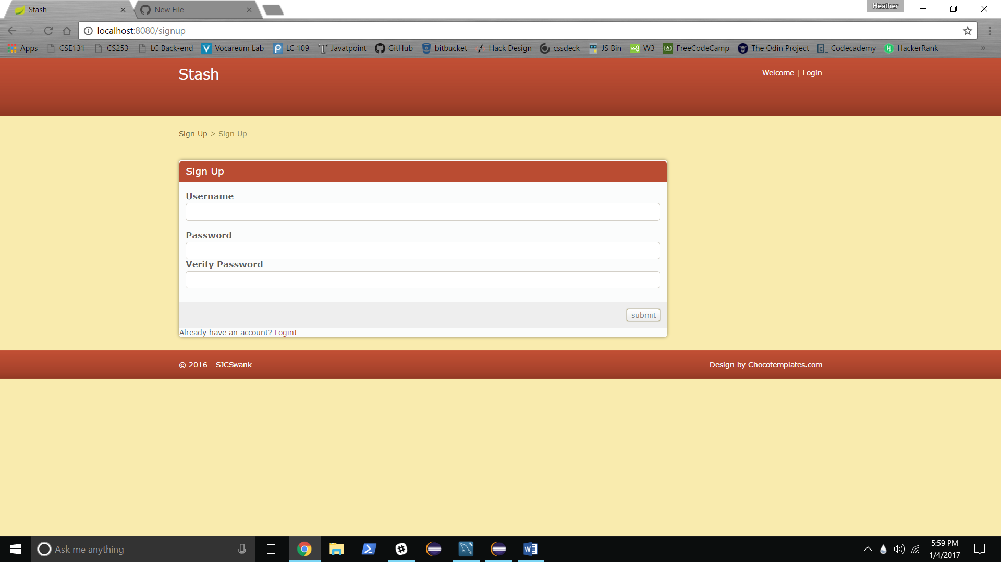

Current Status: All links and verification work. Error messages are working but not finalized for formatting.

**Log In Page:**

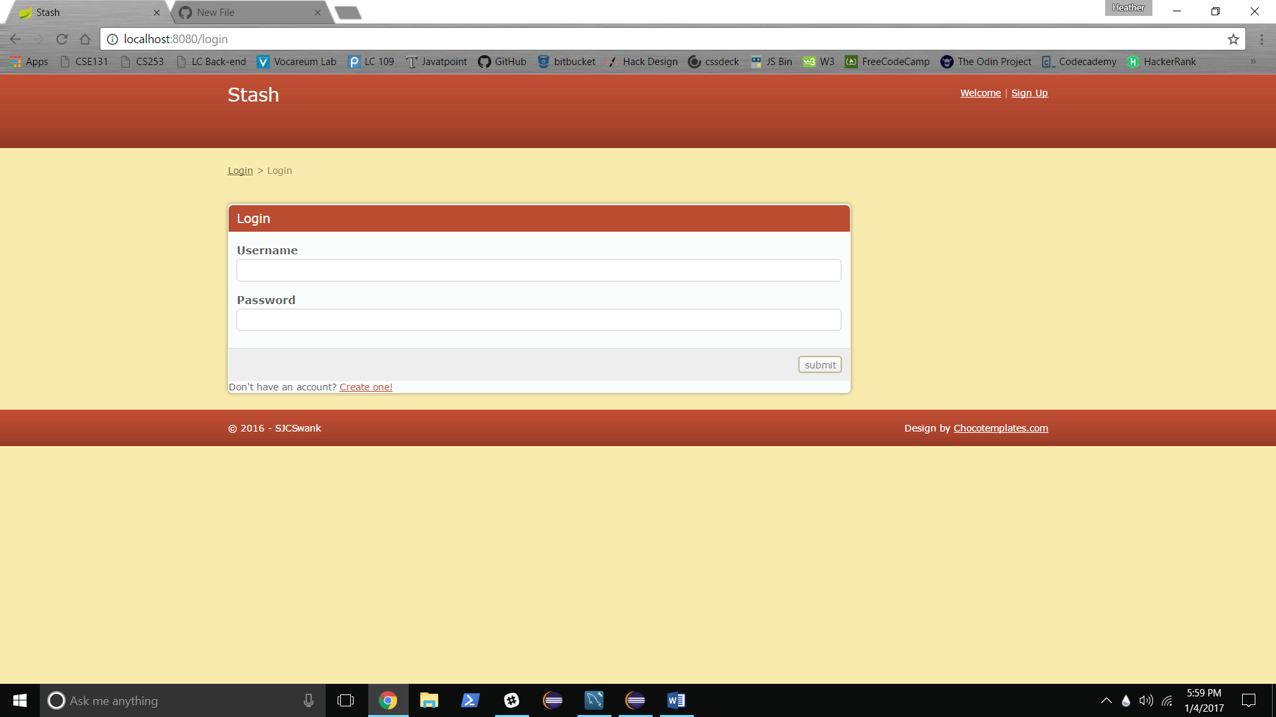

Current Status: See Sign Up Page

**Dashboard Page:**

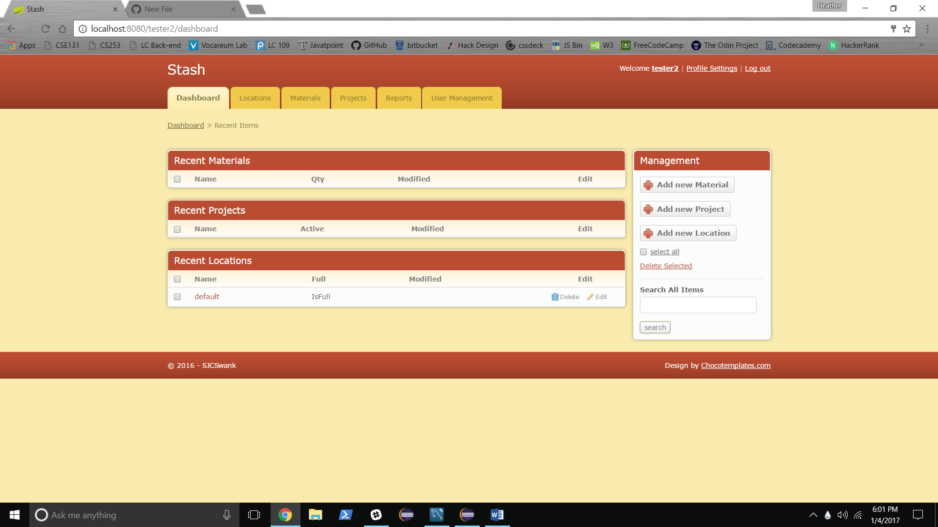

Current Status: Main navigation links Locations, Materials, and Projects work. Link buttons Add new

Materials, Add new Project, and Add new Location work. On sign-up a default location is created and shown in list of recent locations. Recent Materials, Recent Projects, and Recent Locations show the ten most recently modified items from each table. Name of each item links to page of individual item information. Edit, Delete, and search functions are not yet implemented. Profiles, Profile Settings, Reports and User Management are not yet implemented.

From Dashboard Add new Material Screen:

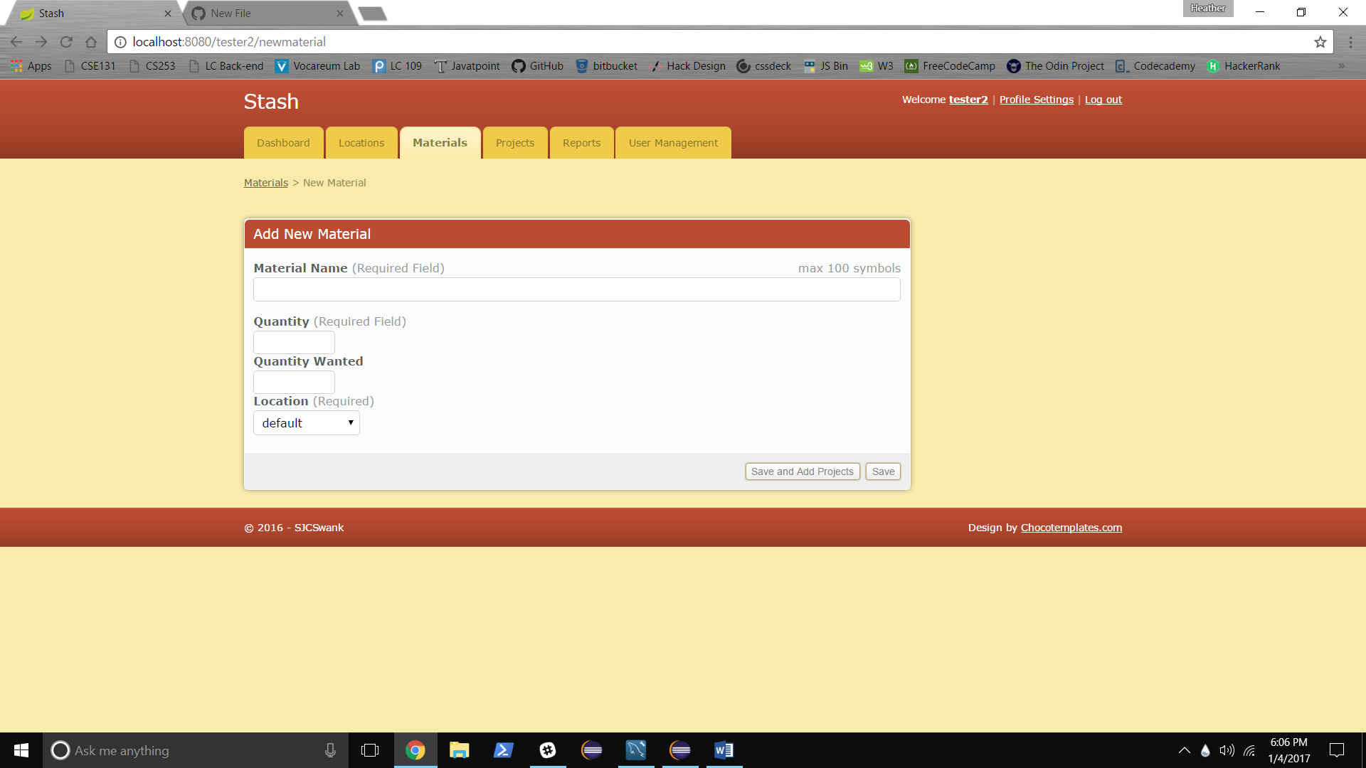

Redirects to created material permalink:

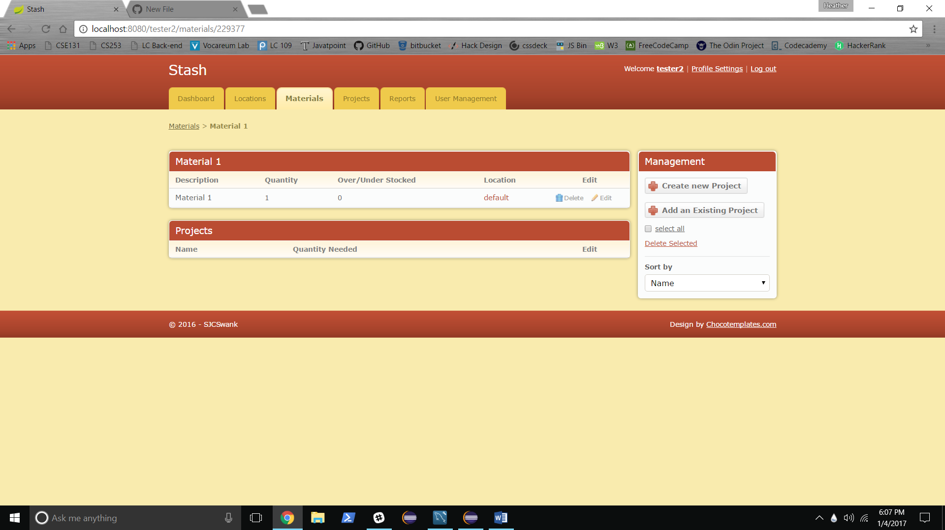

From Dashboard: Add new Project Screen:

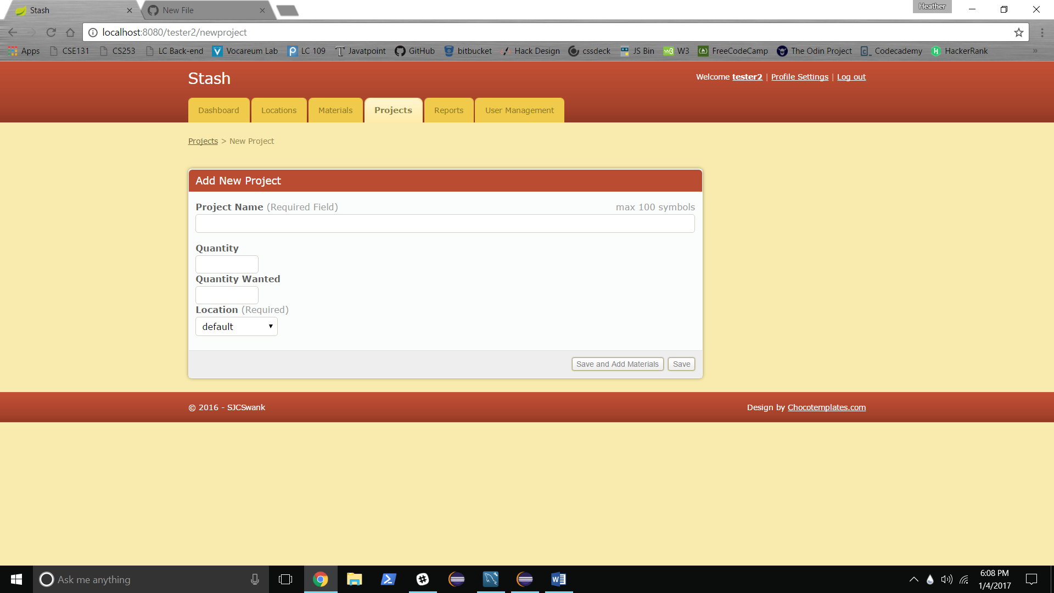

Redirects to Created Project Permalink:

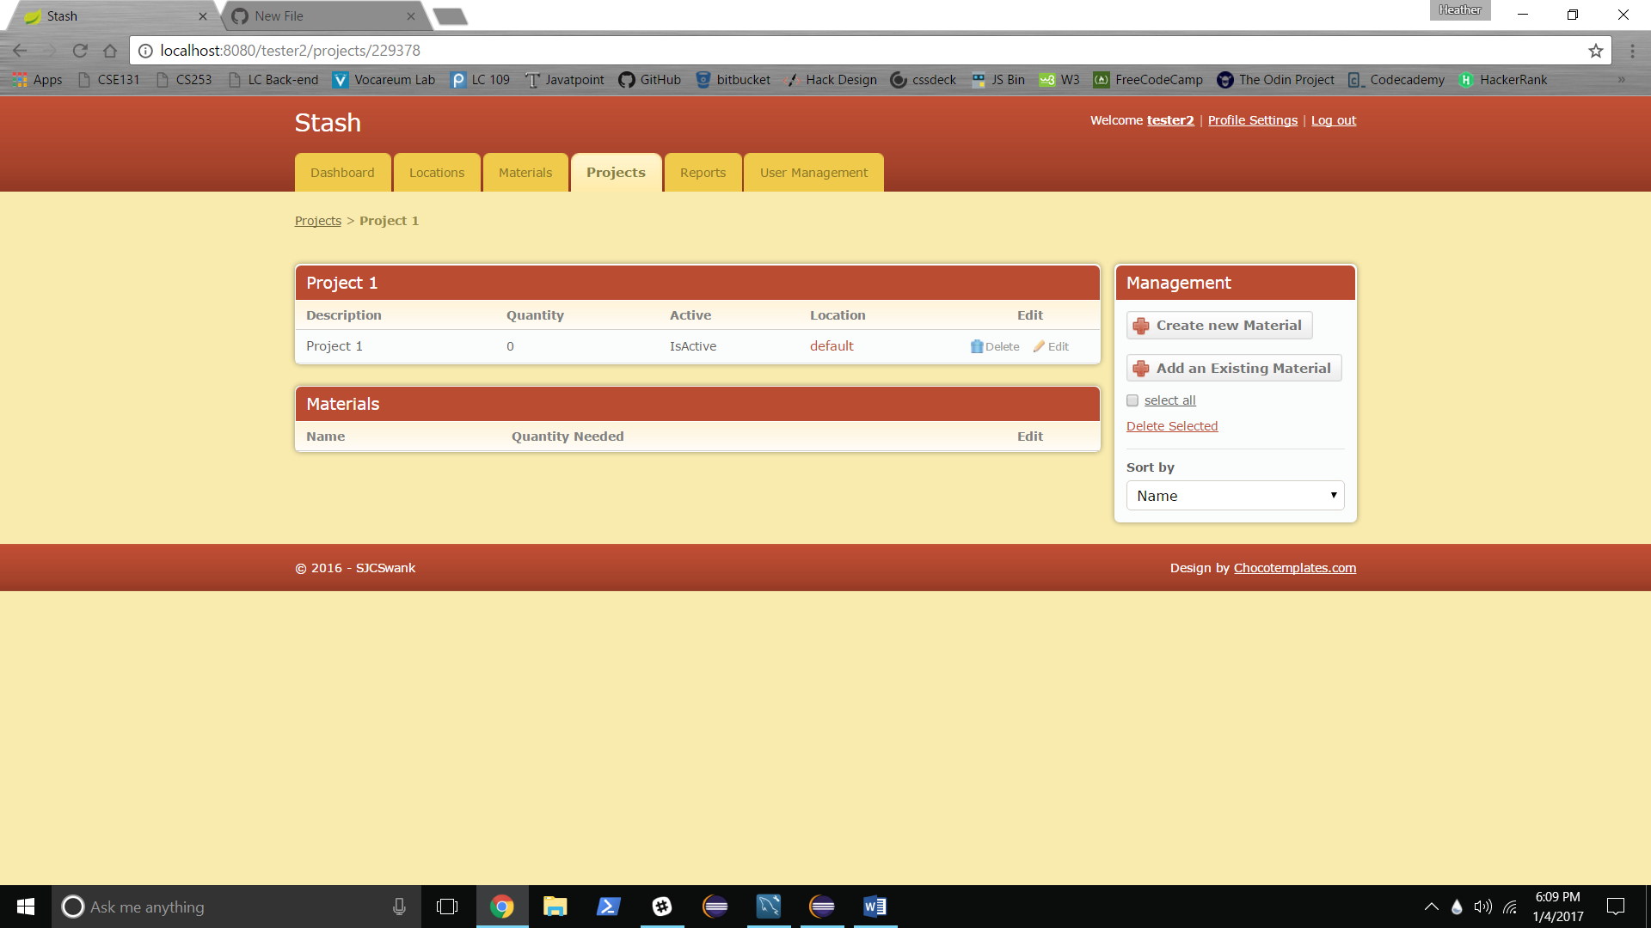

From Dashboard: Add new Location screen:

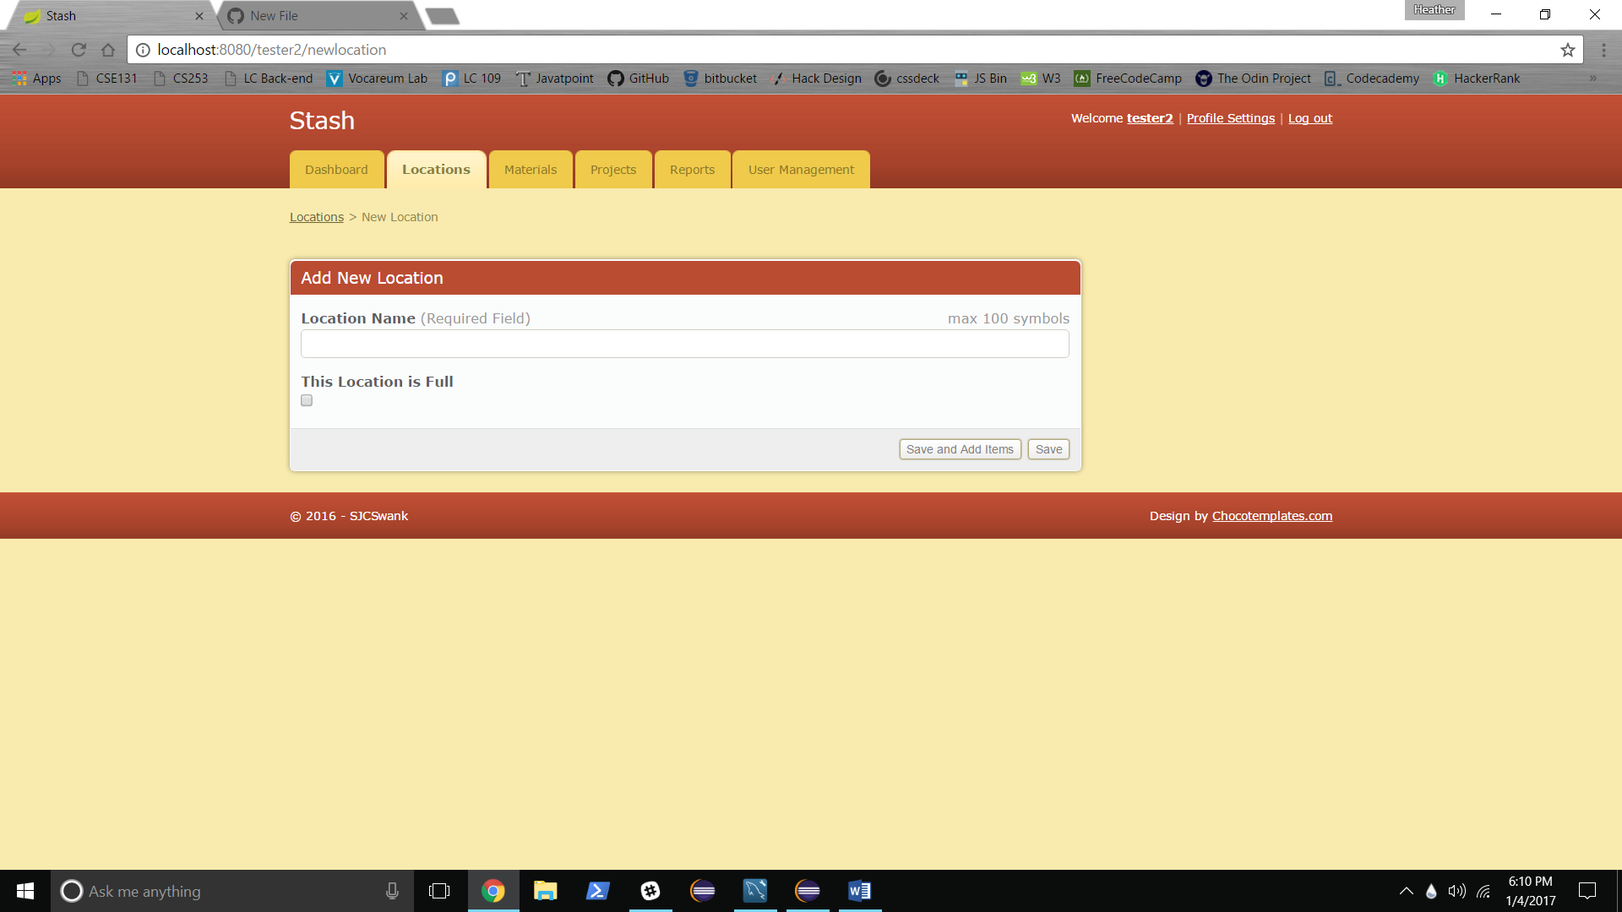

Redirects to Created Location Permalink:

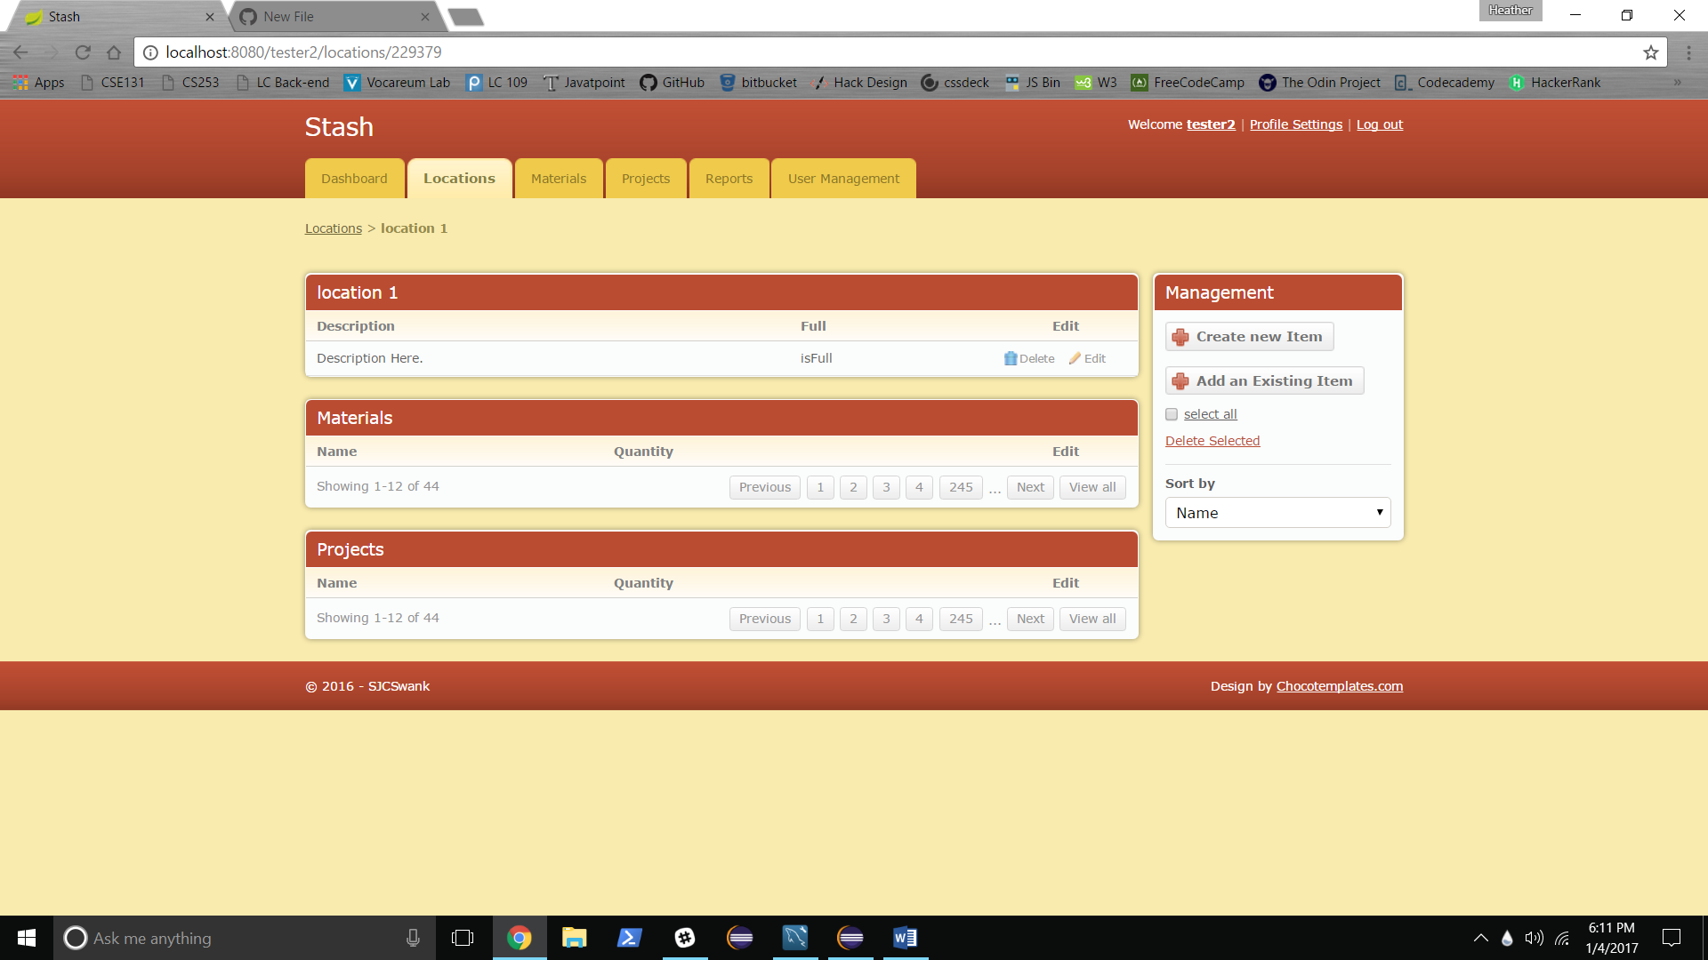

Dashboard after adding items:

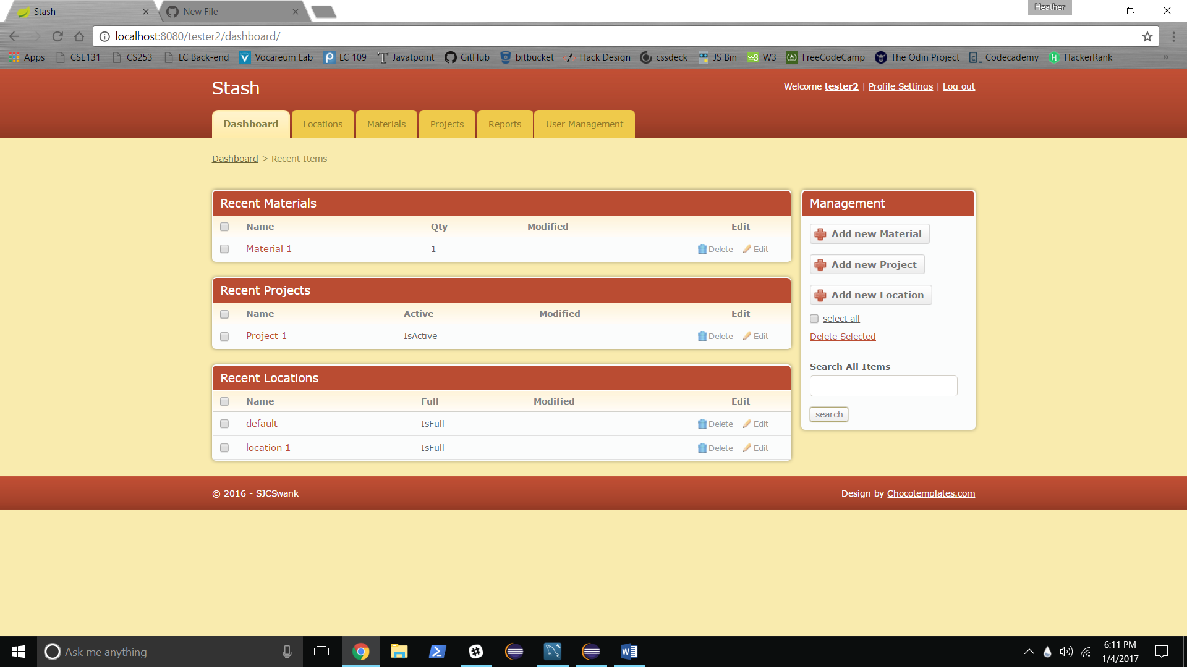

**Locations:**

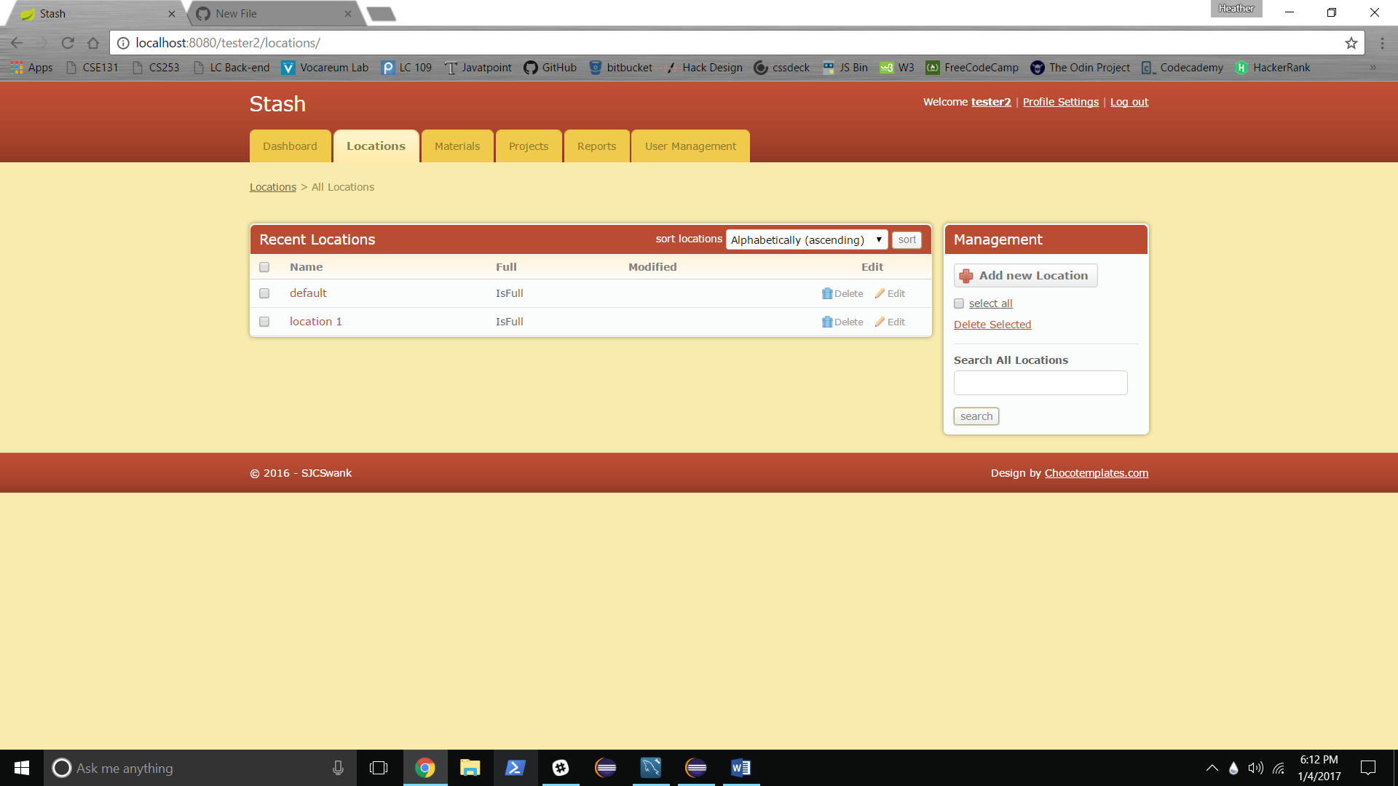

Current Status: Same main navigation status as dashboard. Add new Location same as Dashboard. Edit, delete, select all and delete selected functions not yet implemented.

Sort:

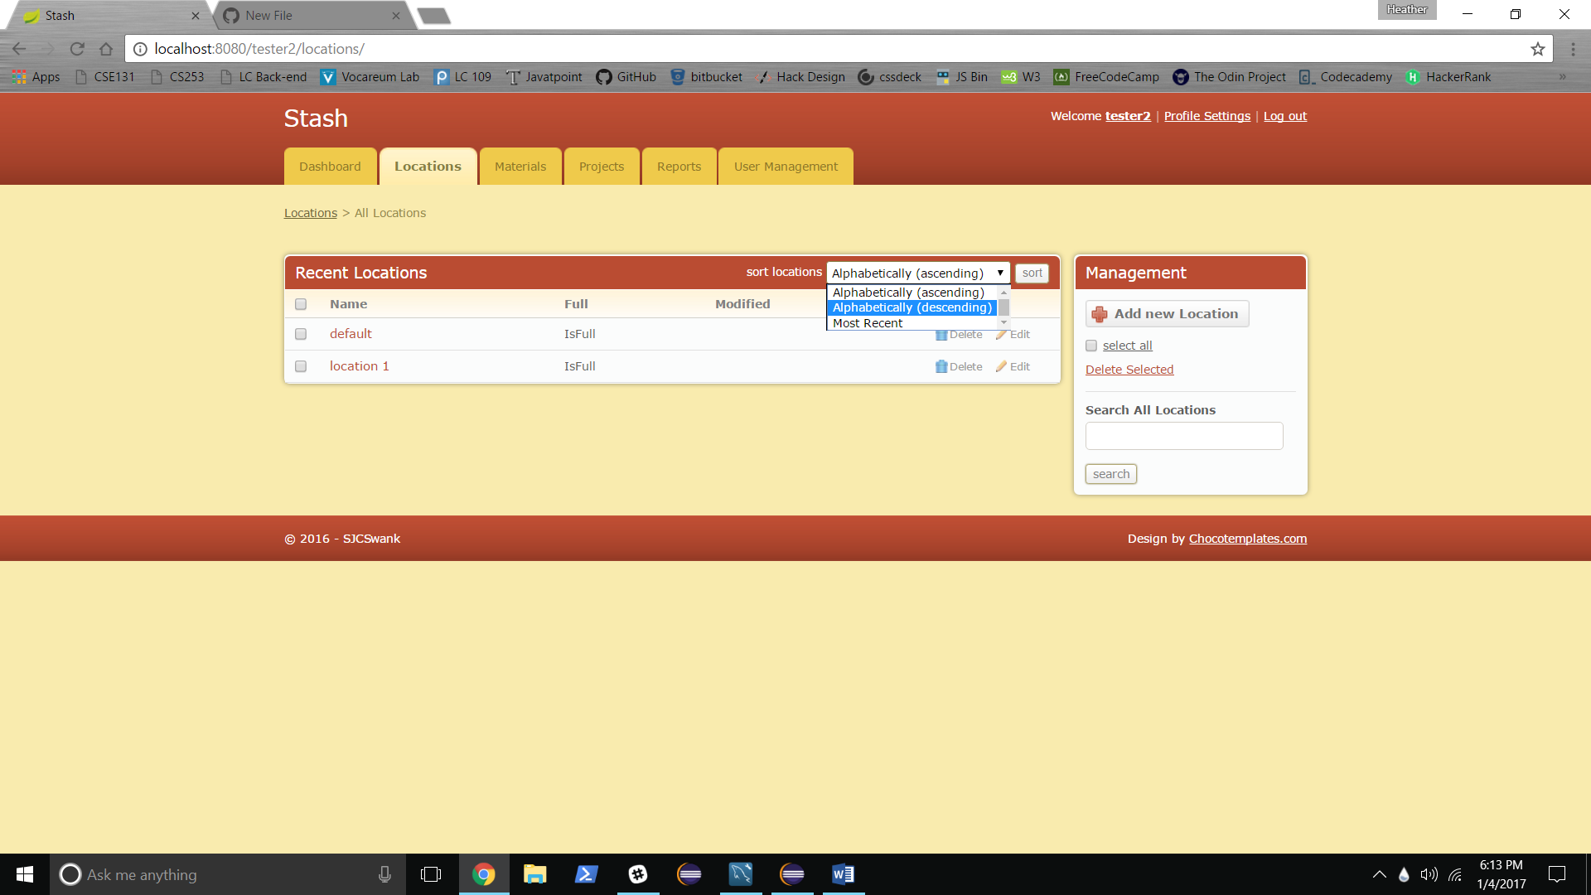

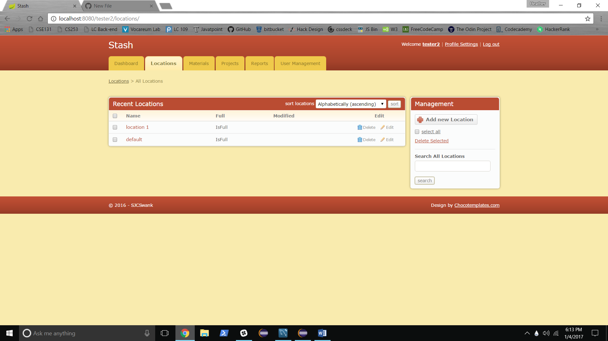

Search:

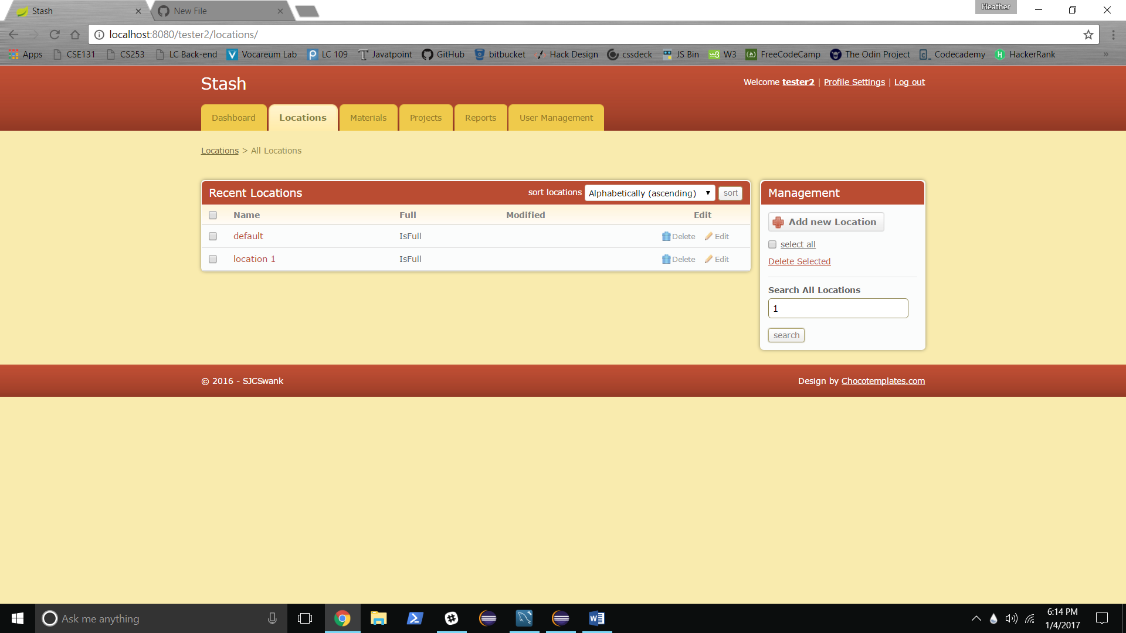

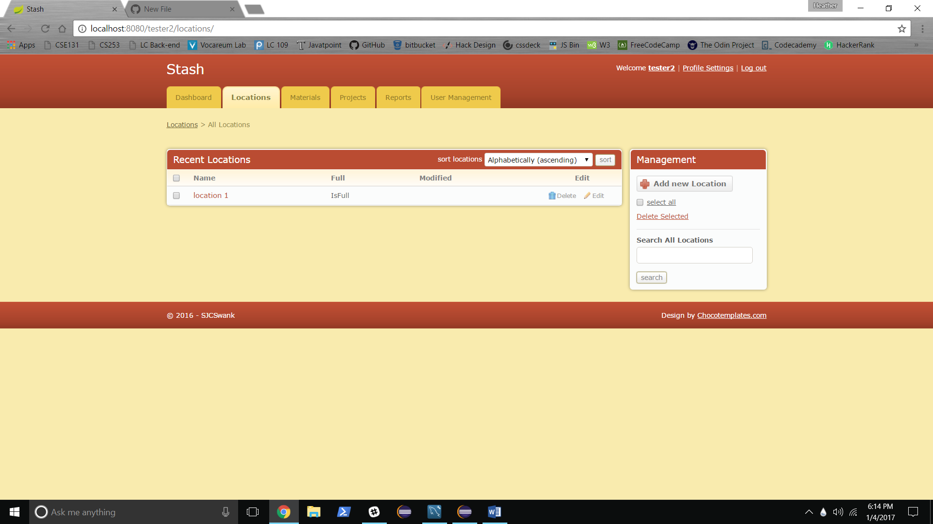

**Materials Screen:**

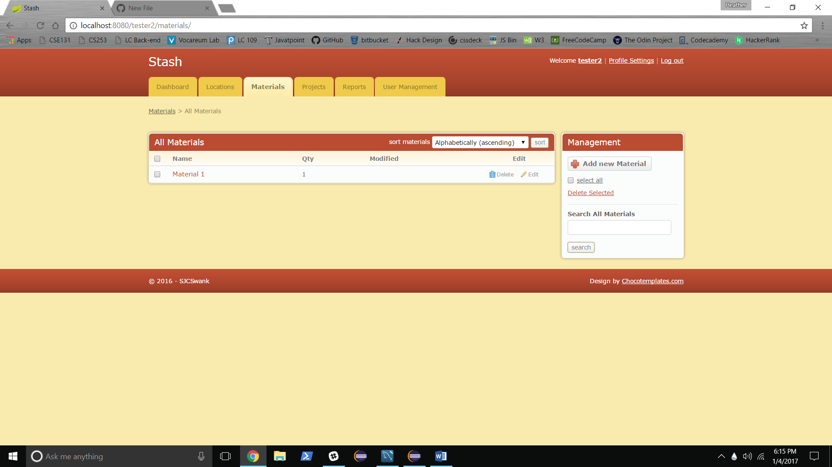

Current Status: See Locations Screen

**Projects Screen:**

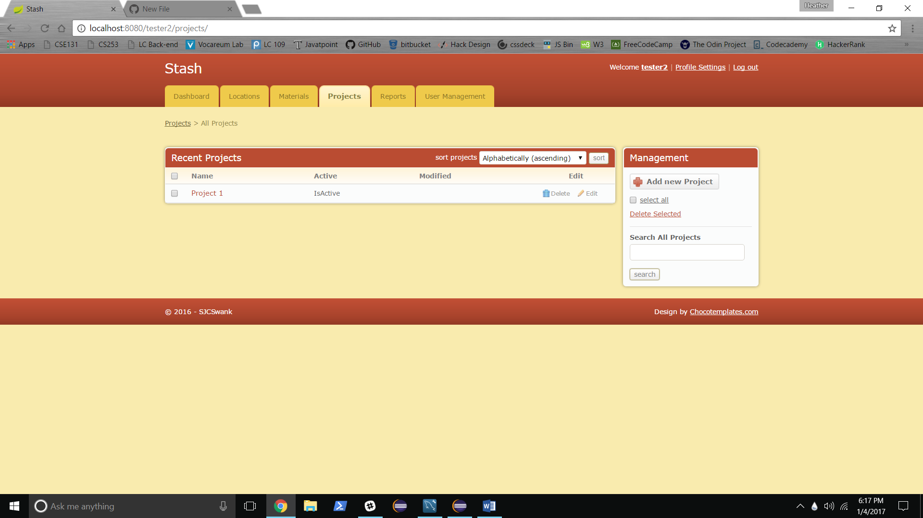

Current Status: same as Locations screen.

**Individual Location screen:**

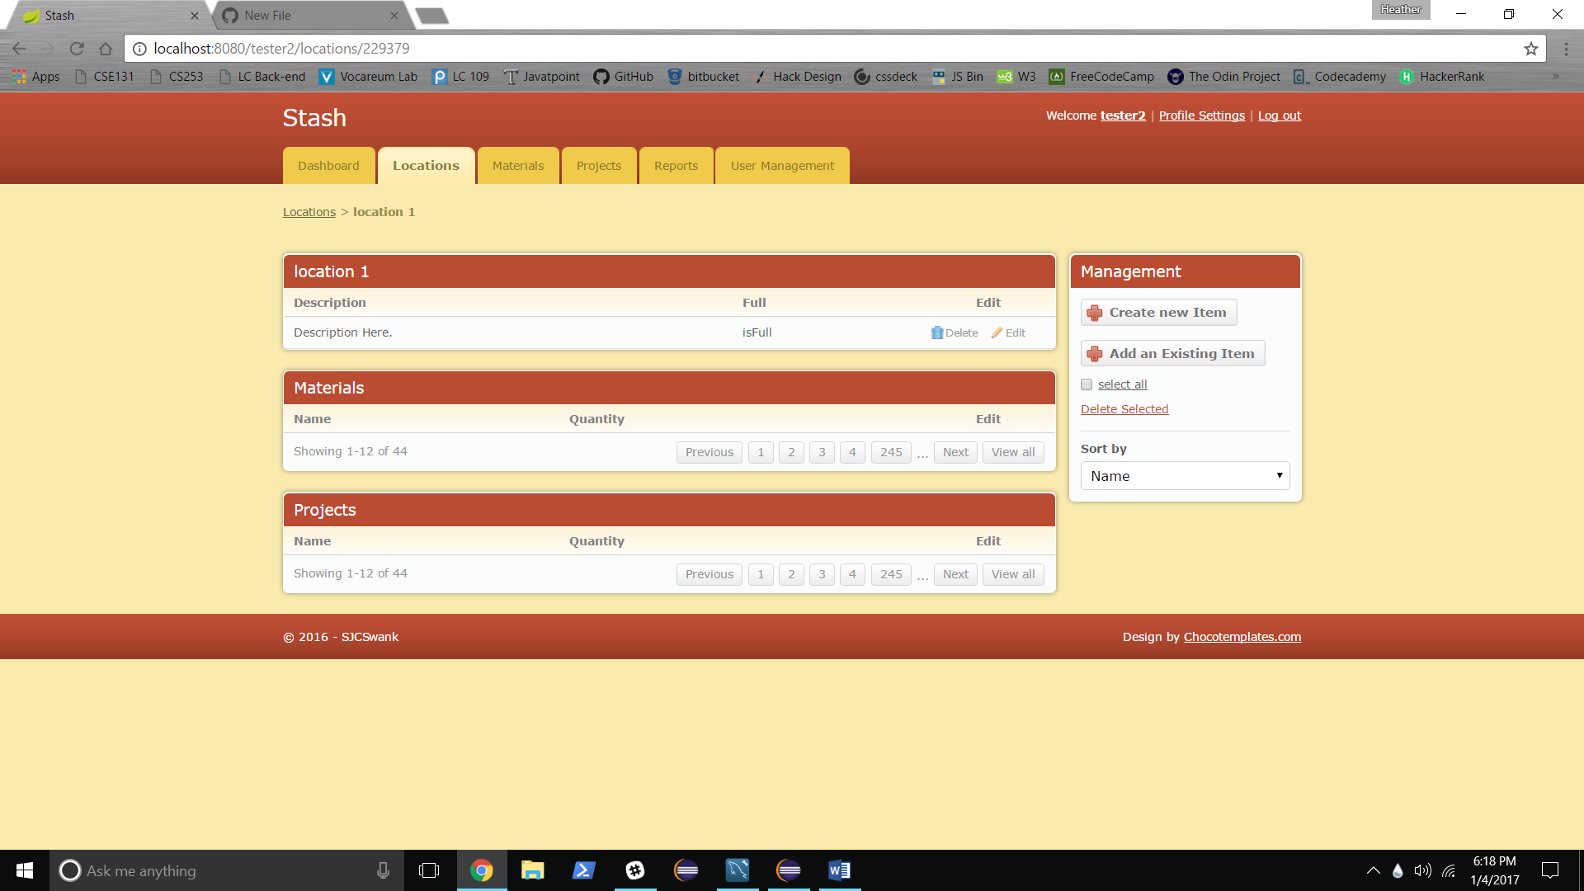

Current Status: Main navigation same as dashboard. Edit, delete, select all, delete selected not yet implemented. Sort and Search not yet implemented.

Create New Item Link Button:

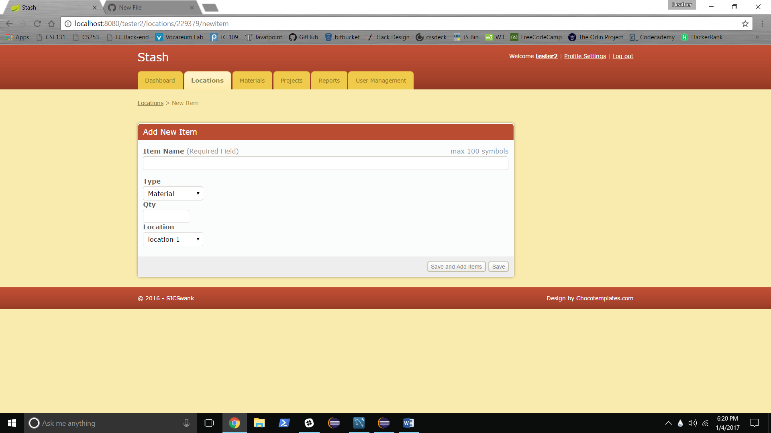

Redirects back to Location permalink with new item added:

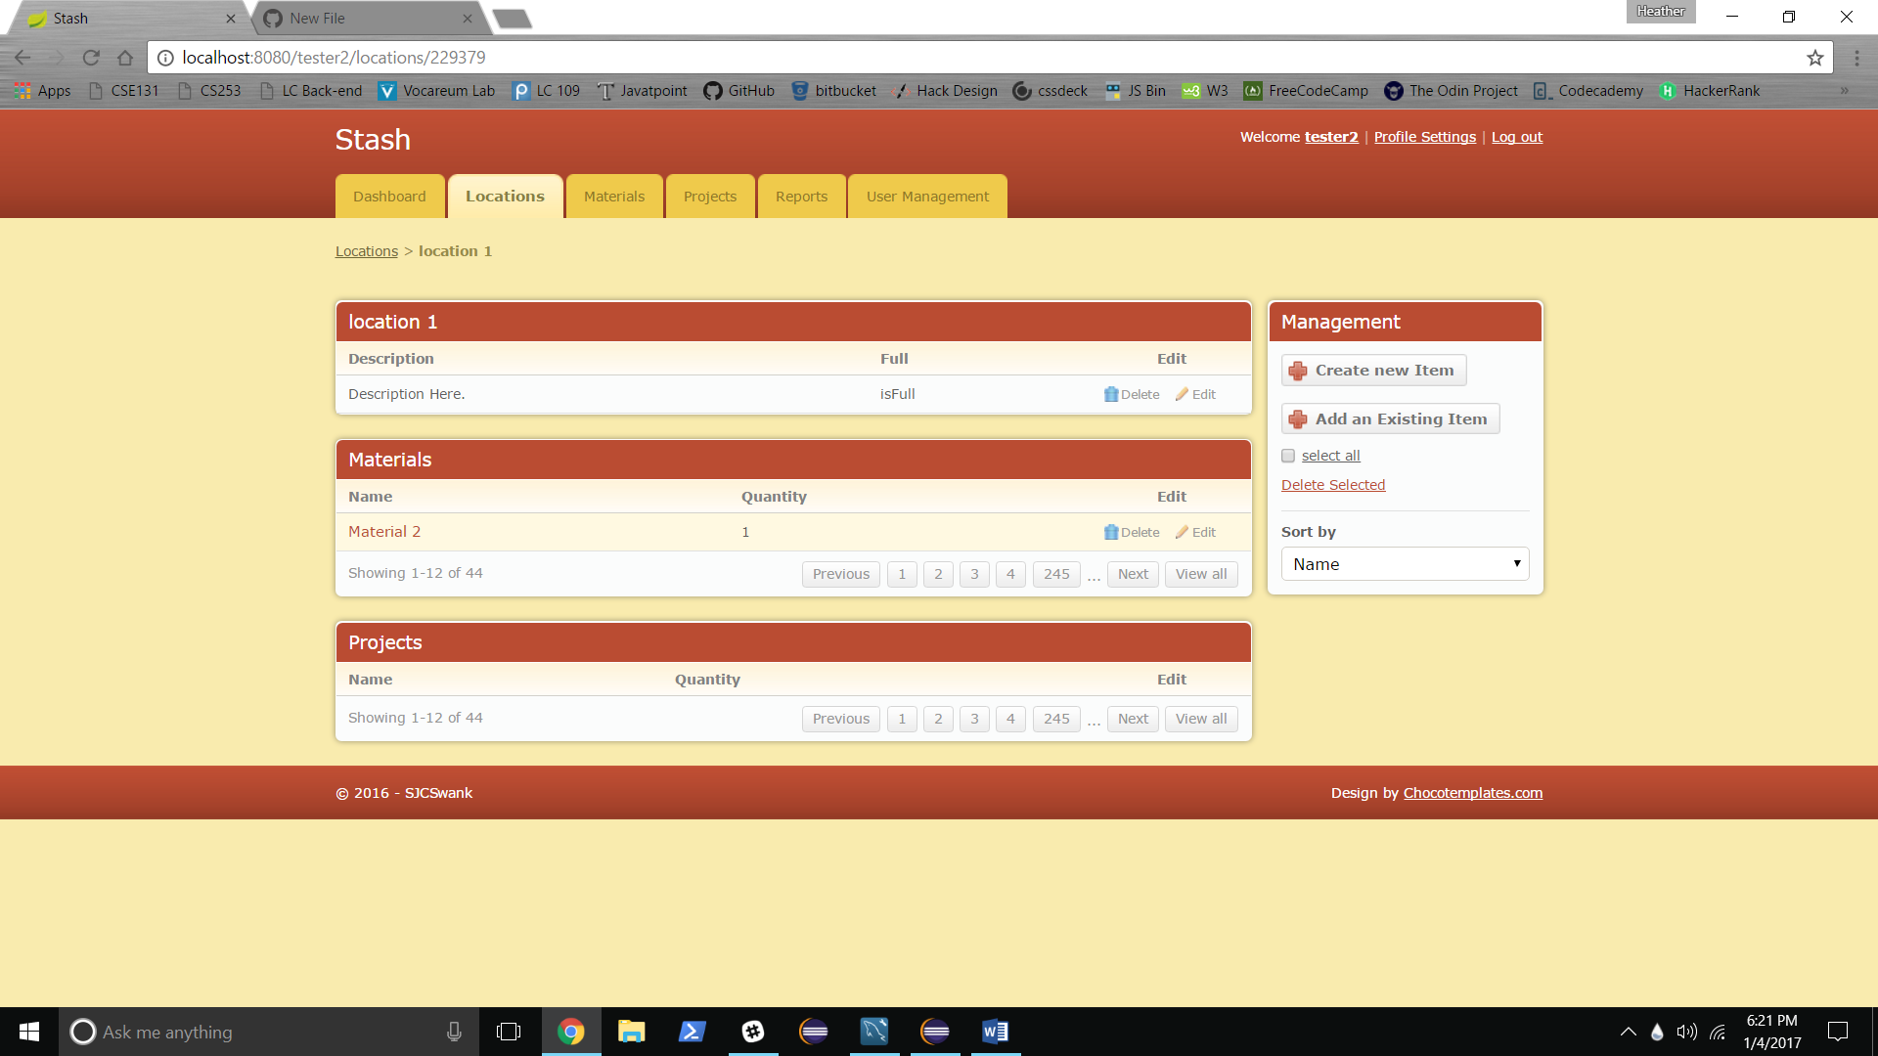

Add an Existing Item link button: 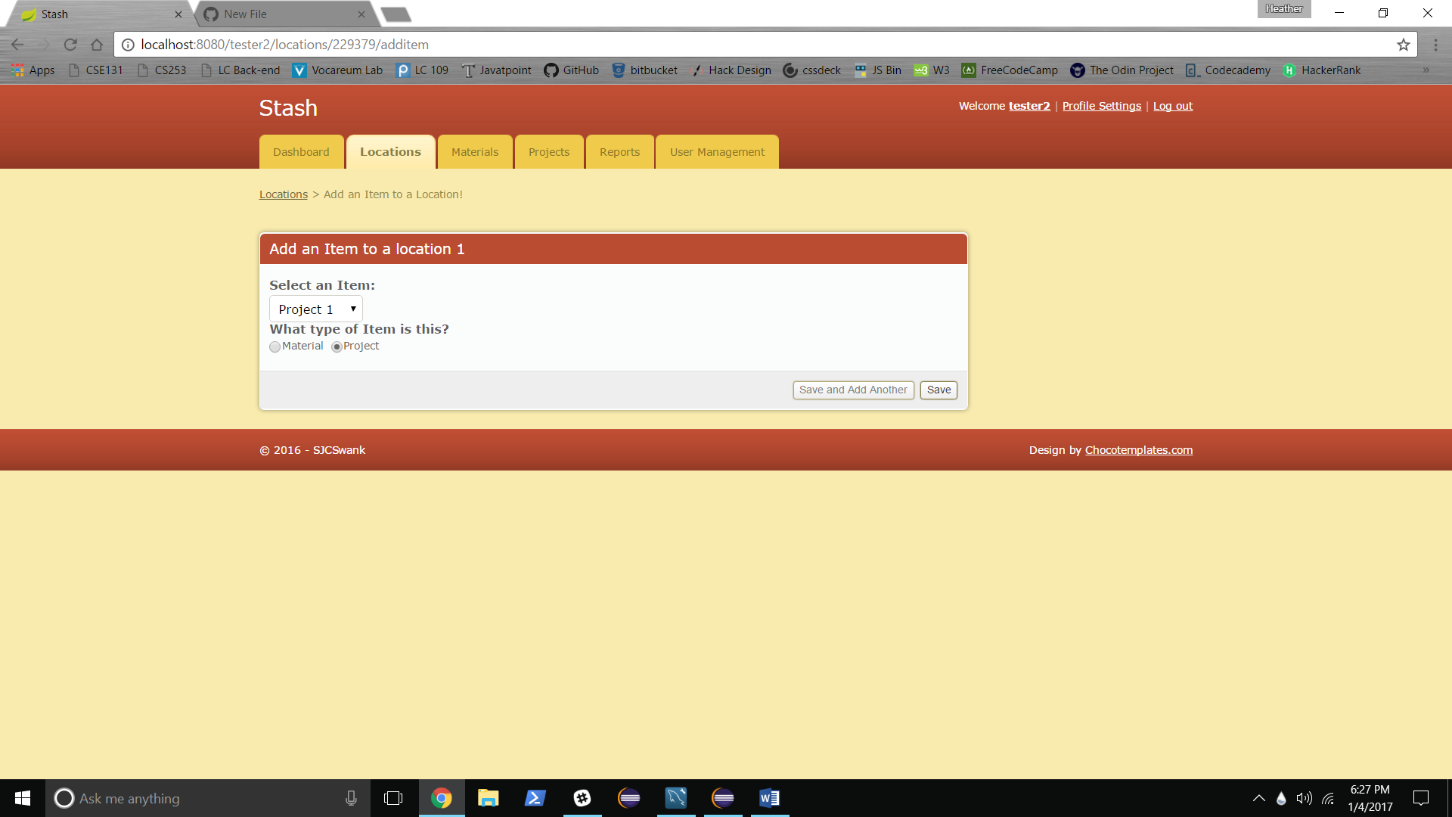

Redirects back to Location permalink with item added:

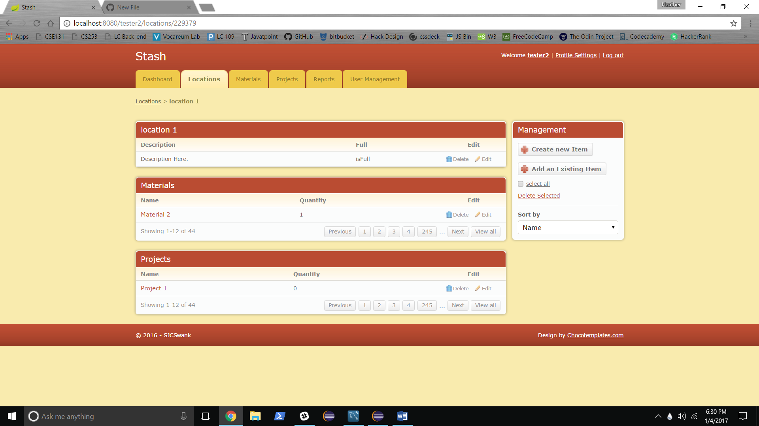

**Individual Material Screen:**

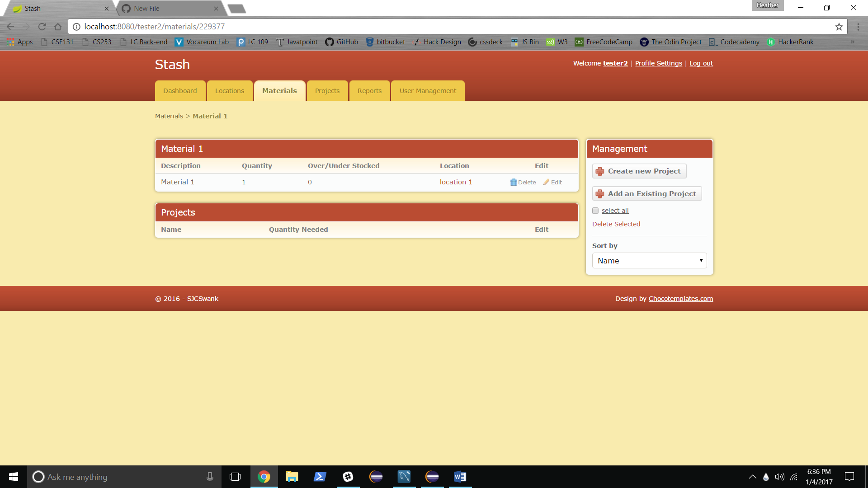

Current Status: Main Navigation same as dashboard. Edit, delete, select all, delete selected, sort and search not yet implemented.

Create new Project screen:

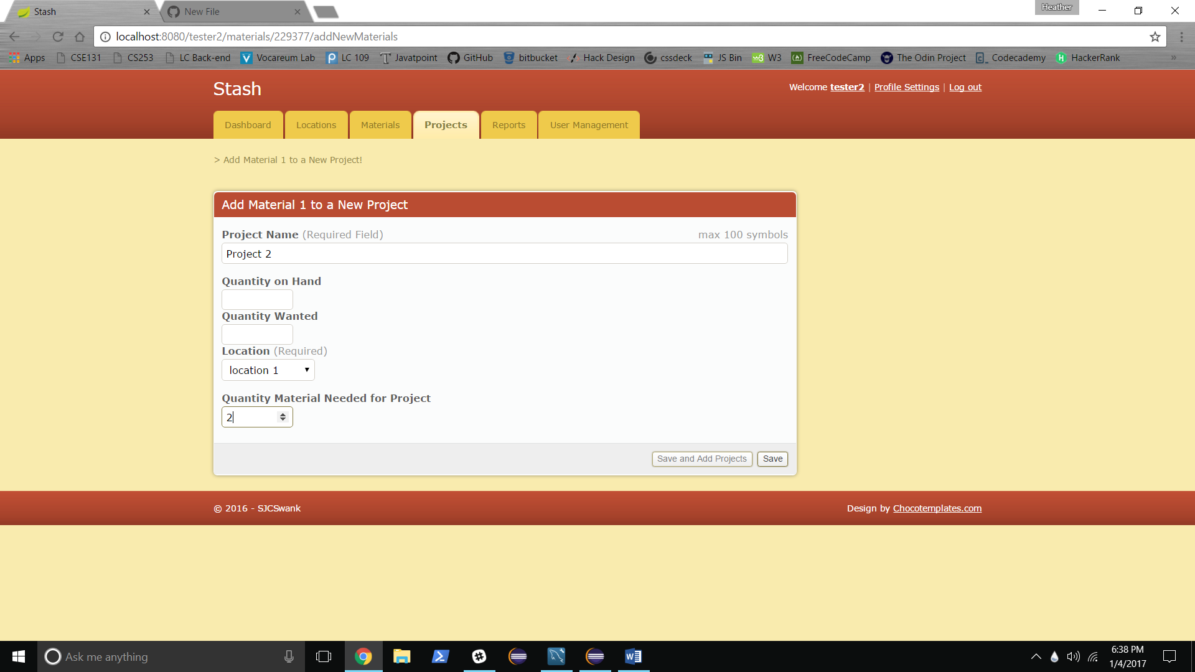

Redirects to back Material Permalink with Project added:

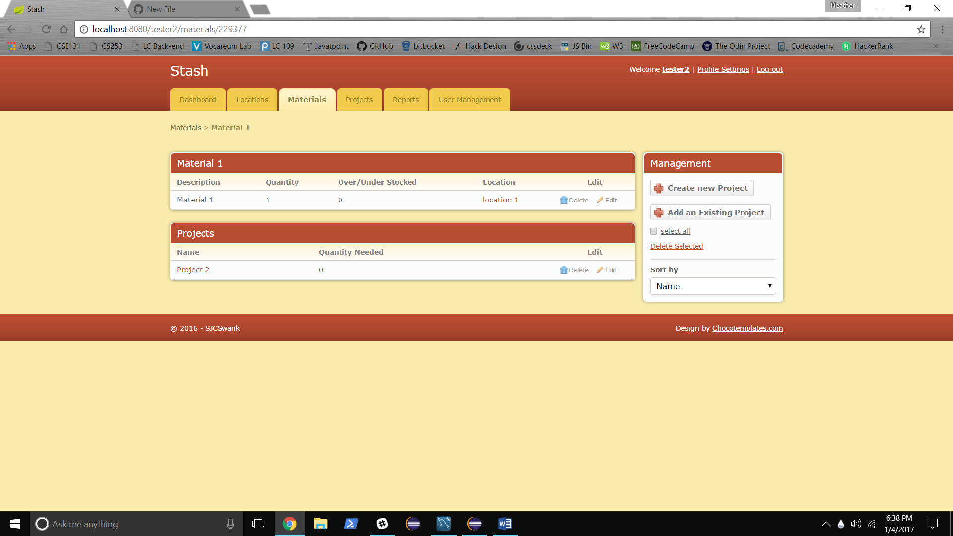

Add an Existing Project Screen:

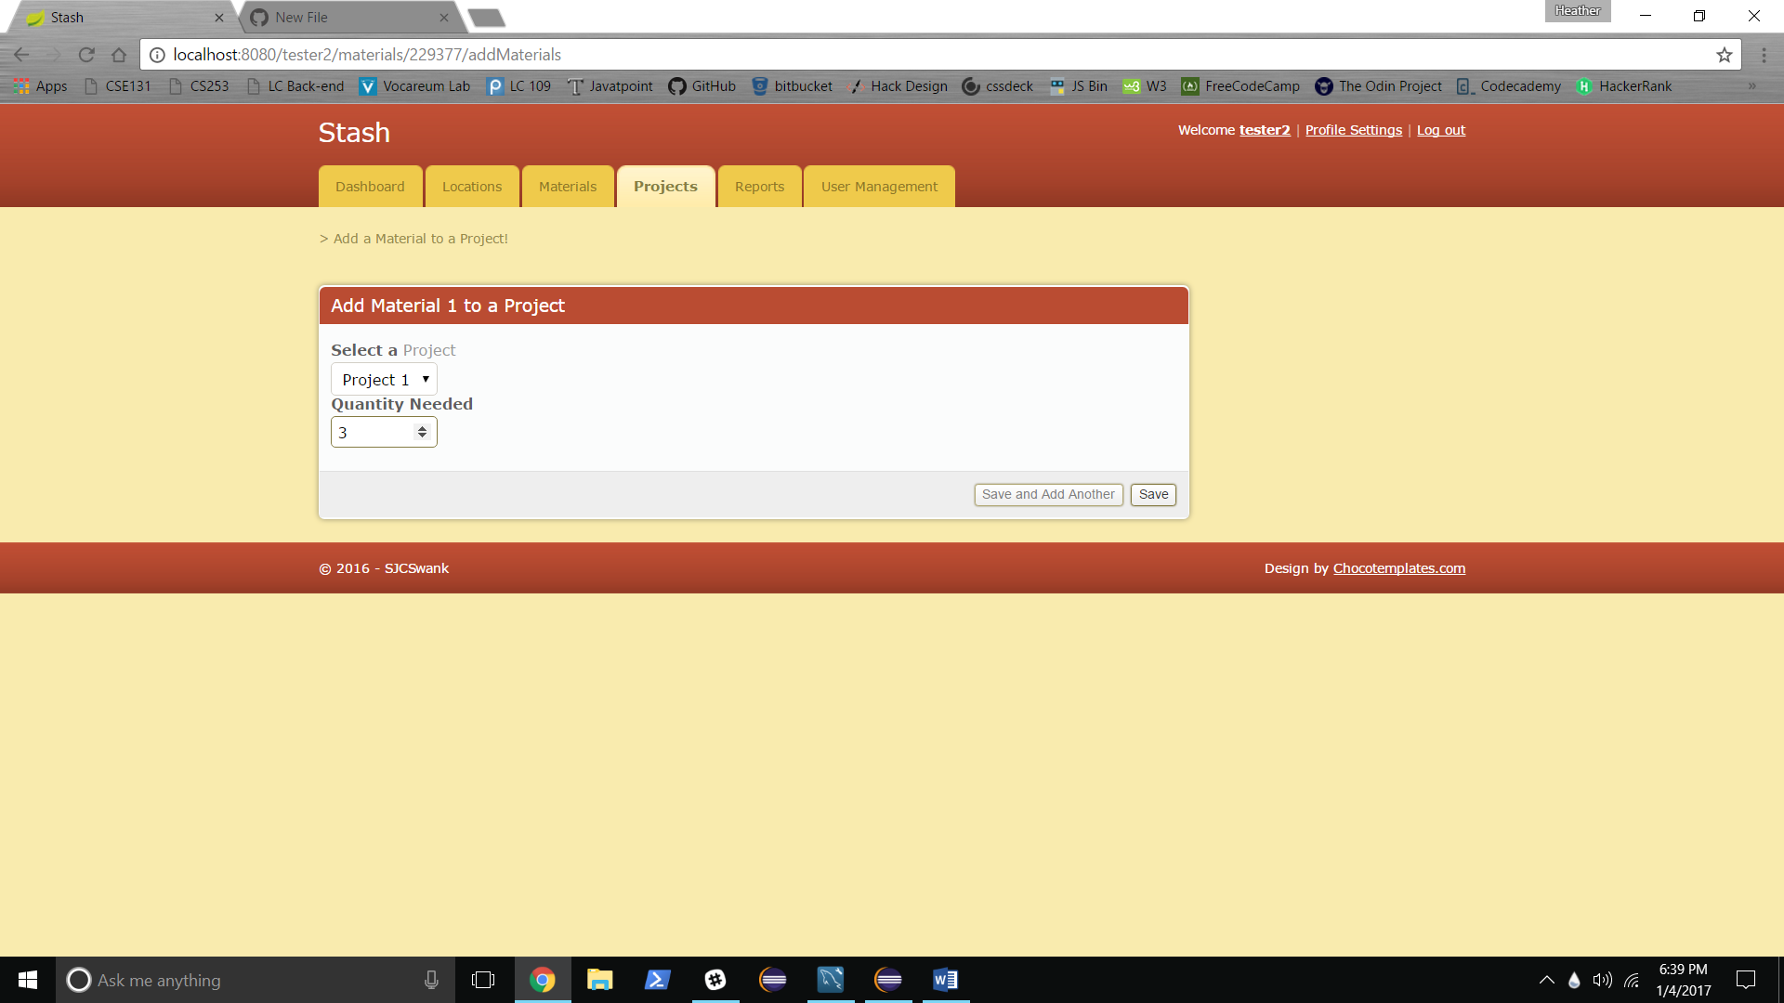

Redirects to back Material Permalink with Project added:

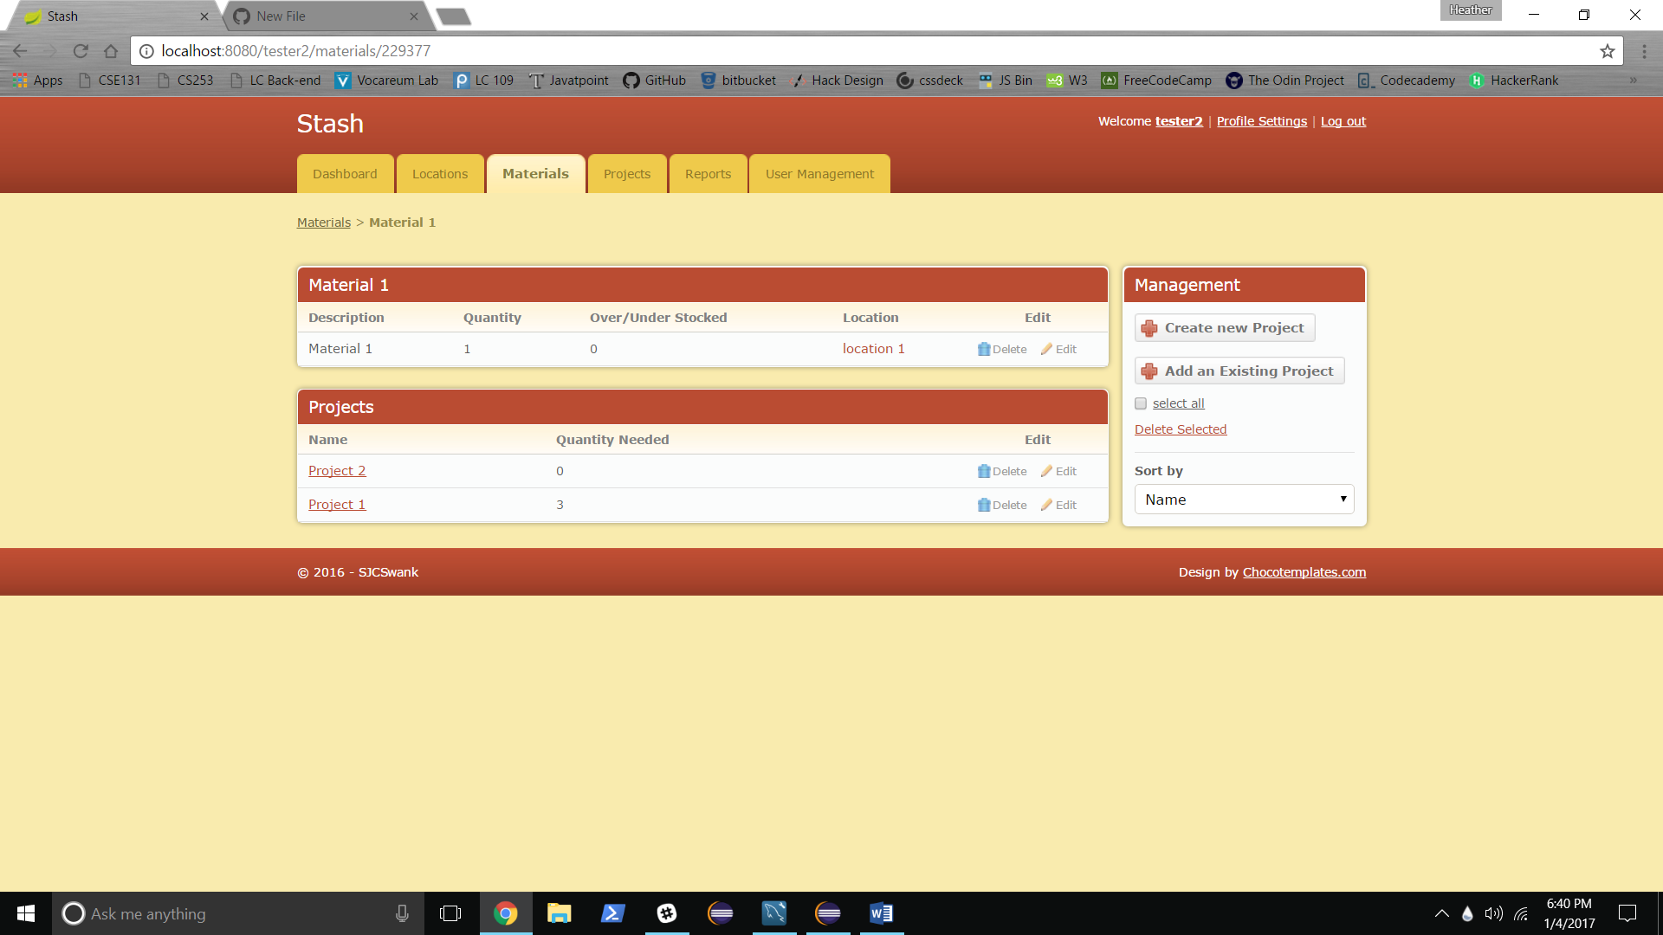

**Individual Project Screen:**

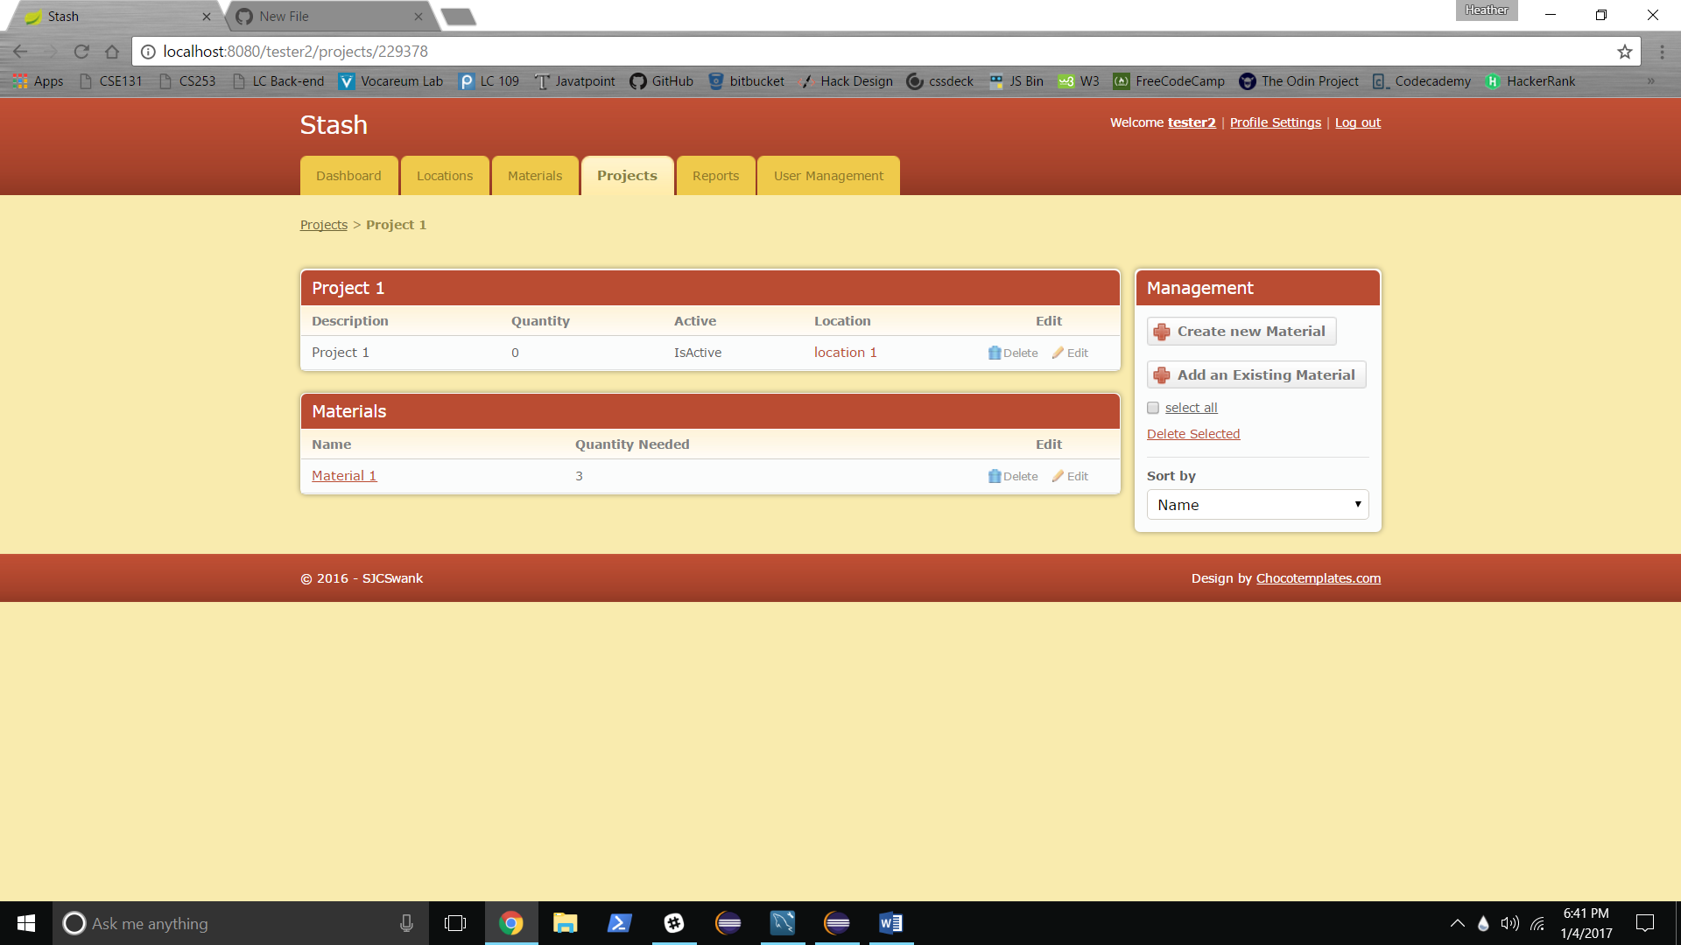

Current Status: Same as Individual Material Screen.

Create new Material link button:

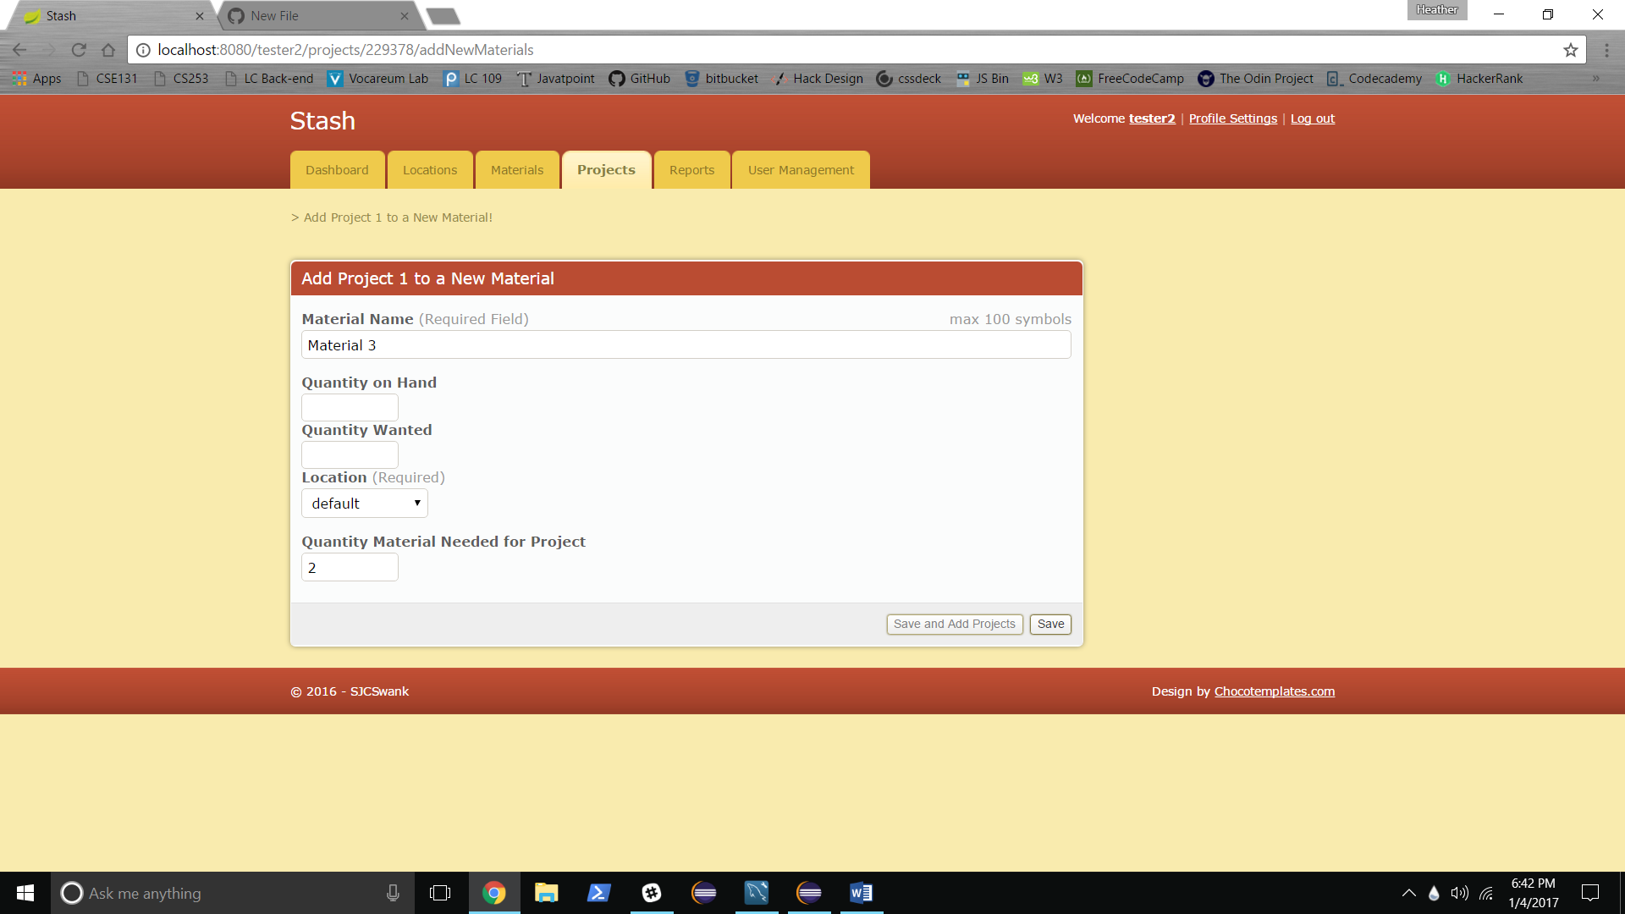

Redirects back to project permalink with new item added:

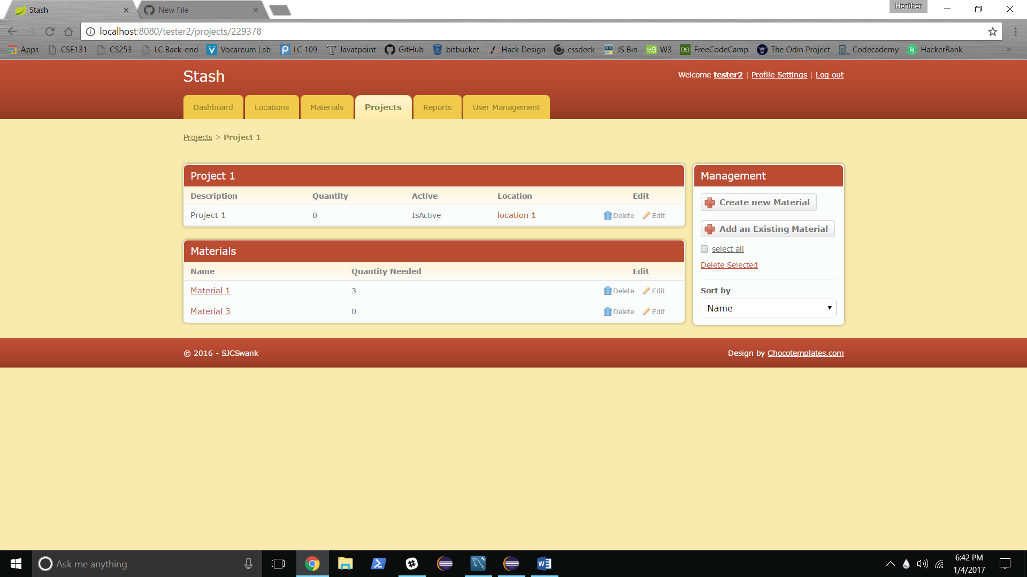

Add an Existing Project link button:

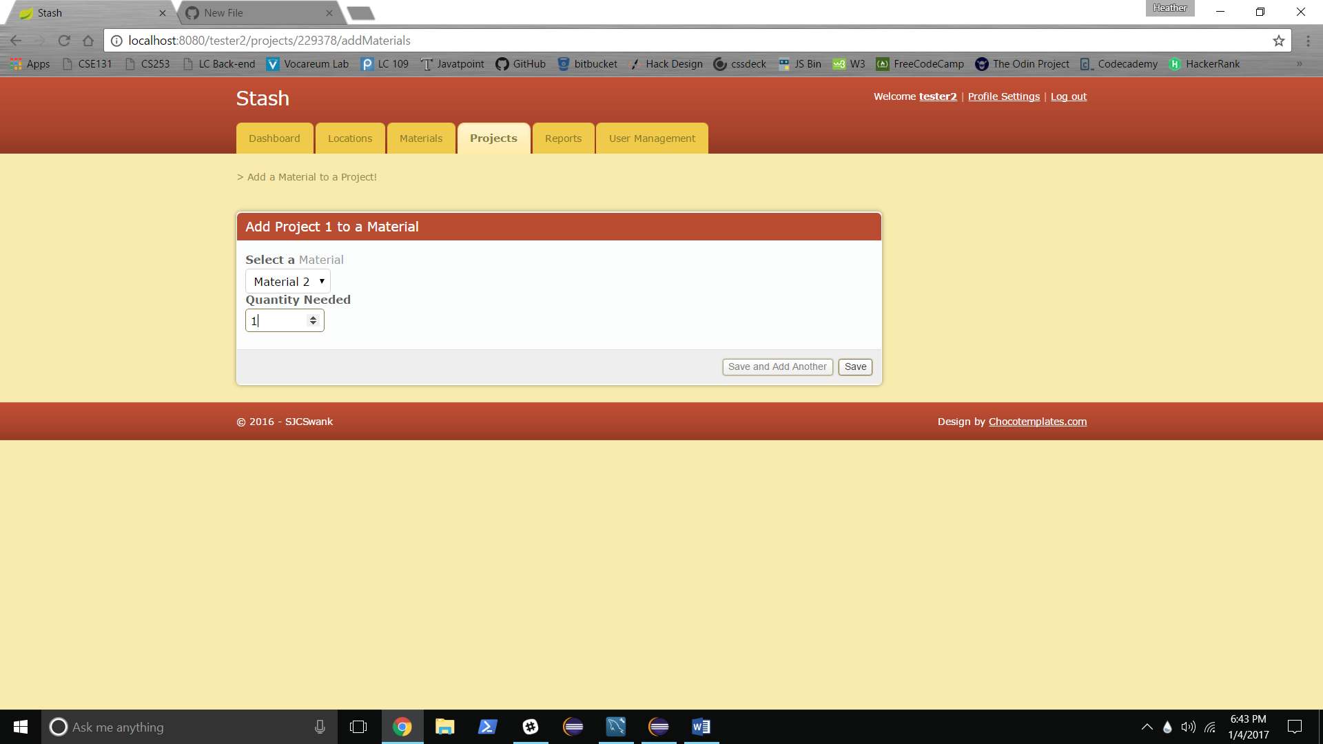

Redirects back to project permalink with new item added:

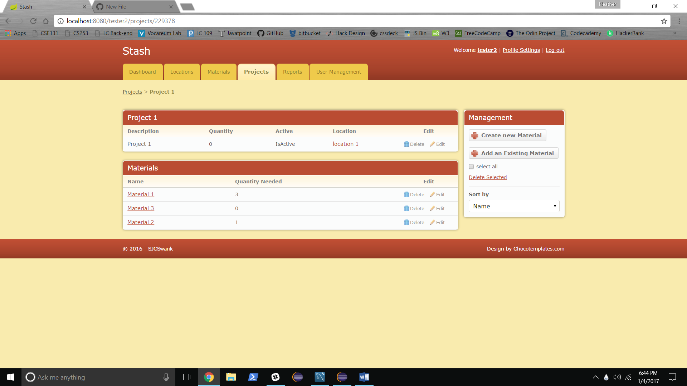

**General Information:**

On all add or create screens, clinking the “save and add another” link buttons save the current item and re-renders the add or create screen.

On all screens: clicking logout removes the user from the session and redirects to the login page.

**Known Issues:**

When creating a new item from any individual view the quantity needed is not stored in the database.

Search parameter on both Materials and Projects pages is not being found.

Individual view can and should be consolidated into one template. Same for type dashes (locations, etc.).

**Next Steps:**

Addressing all known issues.

Adding Edit, Delete, Select All, Delete Selected, Search and Sort features where not implemented.

Adding User profile page with ability to edit.

Adding additional information such as descriptions, location isFull, project isActive, material and project wanted quantity, material available quantity (number currently in stock minus number currently in ACTIVE projects).

Adding the following reporting features:

Materials and Projects under or over stocked (< or > quantity wanted)

All or more than a programed percentage of Locations full

Weekly, Monthly, Quarterly, and Yearly stock adjustment reports (stock out and stock in)

Weekly, monthly, quarterly and yearly usage reports (locations added to and removed from, projects made active, materials used in active projects)

Adding User Management functionality including:

Admin users (CRUD)

Management Users (CRU)

Standard Users (R)

Admin ability to CRUD all users

Admin reports on user activities